**Christopher King**

**2018141521058**

**Applied Fluid Mechanics**

**Class Section 01**

**06/08/2021**

# **Problem 12.54**

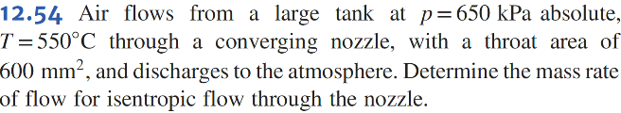

**Solution:**

Therefore, the air is choked flow, for which .

# **Problem 12.58**

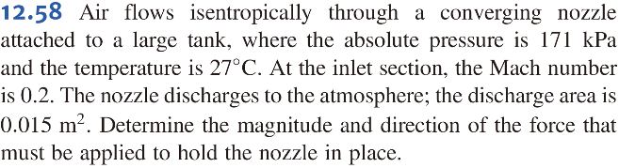

**Solution:**

Therefore, the air is not choked flow.

# **Problem 12.59**

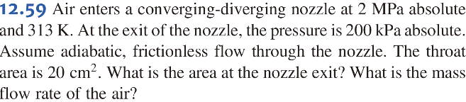

**Solution:**

# **Problem 12.64**

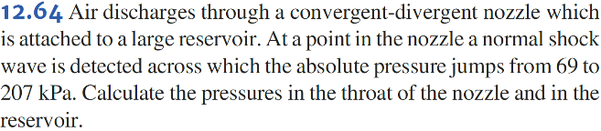

**Solution:**